1. Just like Hammer, Piercing Pattern, Bullish Engulfing Pattern, the lowest low of the 3 candles becomes support area.  
   
2. 
3. 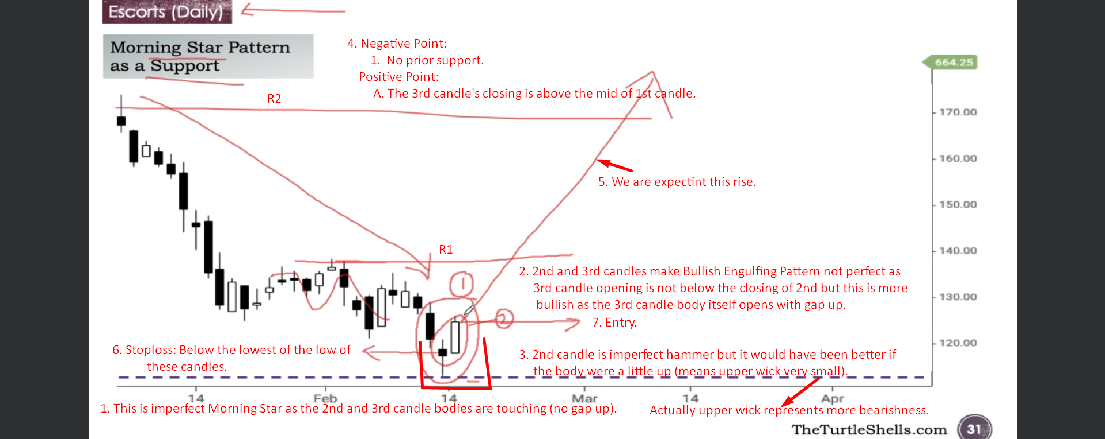
4. 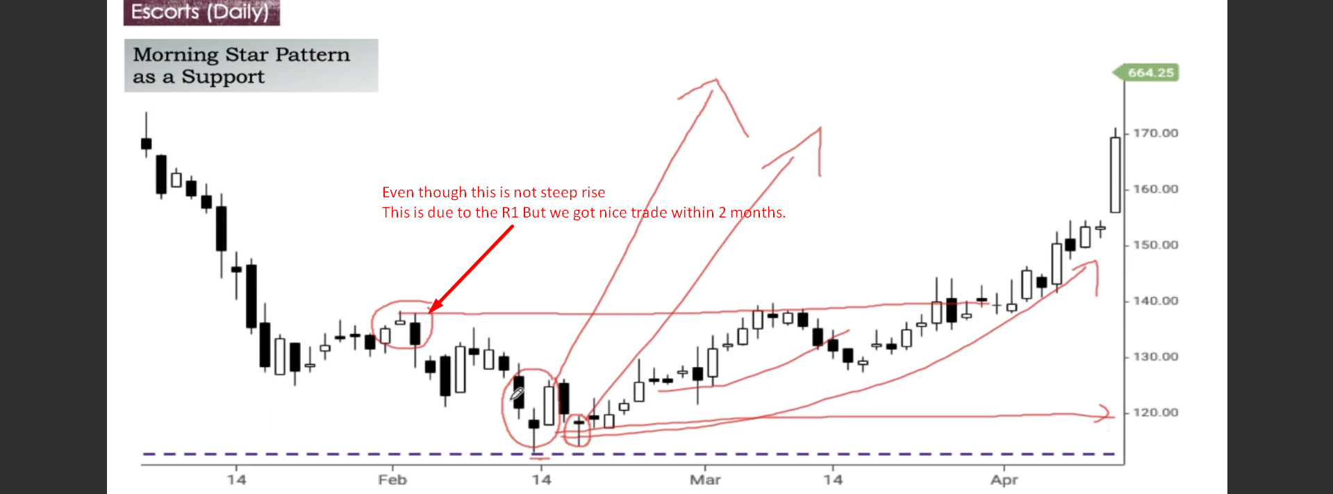  
   In the above slide, note that there is no candle which broke our support area.